# About Presidio:

* Presidio helps to ensure sensitive text is properly managed and governed.
* It provides fast analytics and anonymization for sensitive text such as credit card numbers, names, locations, social security numbers, bitcoin wallets, US phone numbers and financial data.
* It analyzes the text using predefined or custom recognizers to identify entities, patterns, formats, and checksums with relevant context. Presidio leverages docker and kubernetes for workloads at scale.

# Creating a virtual environment using conda and activating the environment.

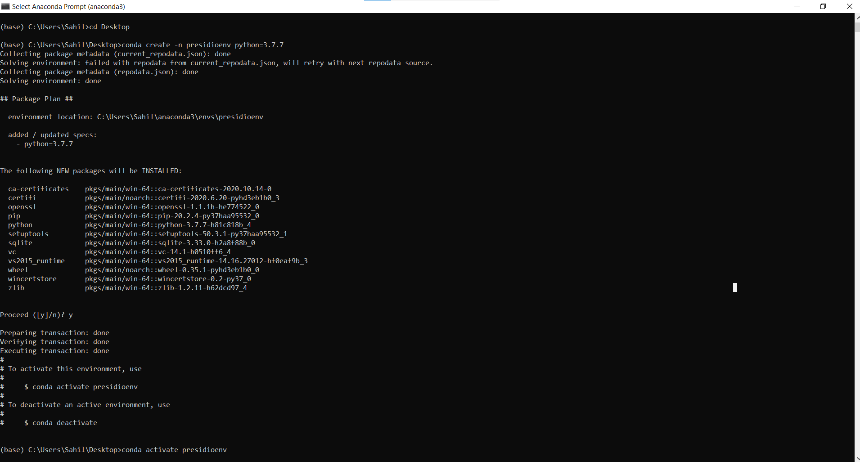

# Navigate into the presidio analyzer folder and create a wheel file.

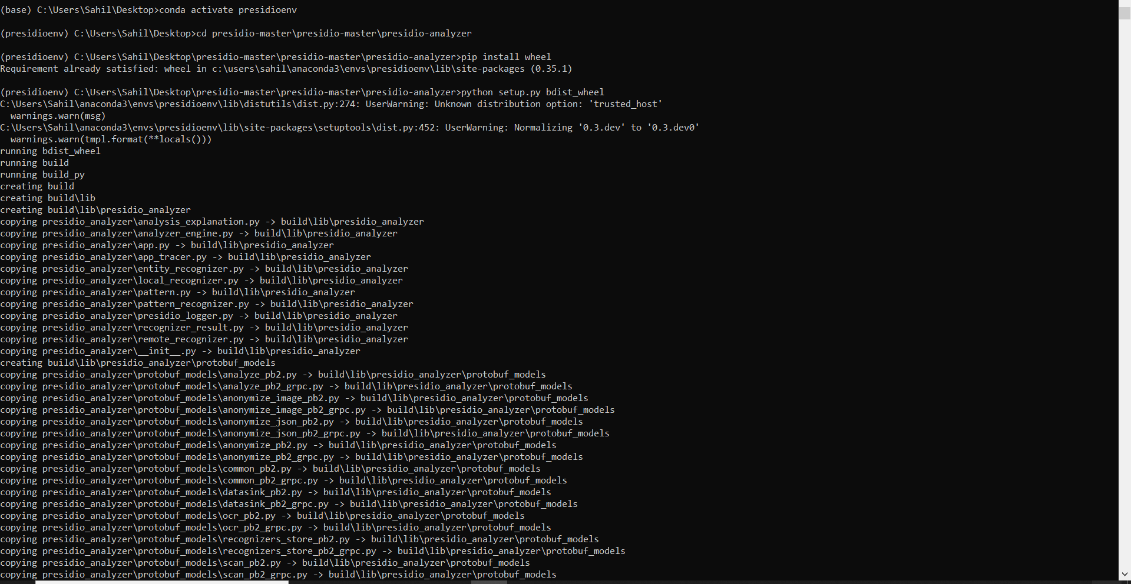

# 

# Install the wheel file that is created in the dist folder.

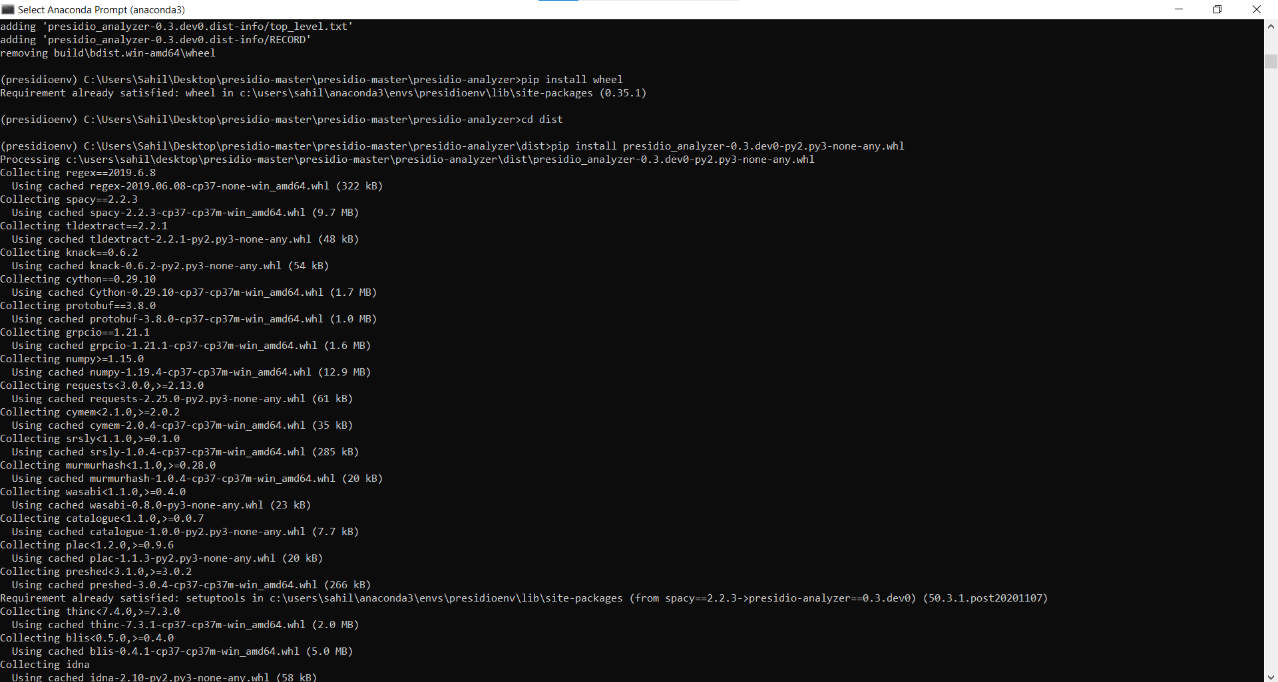

# Download and install the spacy models using the github link

# 

# 

# Create a test python file and put it in the presidio analyzer folder and run the file in the virtual environment.

# 